1. Rehan wants to create directory Practical3 with 10 files & 3 subdirectories. Assign file name as Practical_exY.txt, Replace Y with exercise 1 to 10 & directory name as TempX, Replace X with 1 to 3.

Linux Exercise

1. Now, He wants to redirect a long listing of all content in the Practical3 directory, including hidden directories and files, into a file named editing_final_lab.txt.

1. Edit the file using Vi.

1. He wants to remove the first three lines. Enter line-based visual mode with uppercase V.

1. Also, he wants to remove columns on the first line. Enter visual mode with lowercase v. Lowercase v selects characters on a single line only. The columns after -rw- should be deleted.

1. Remove columns, and the subsequent dot (".") on the remaining lines. Use the visual block mode. Enter visual block with the control sequence Ctrl+V. Use this key sequence to select a block of characters on multiple lines. The columns after -rw- should be deleted.

1. Rehan wants to remove the fourth column. Use appropriate visual mode for the same.

1. Also, he doesn’t want to use time column, so remove the time column using relevant mode to delete column data, leaving the month and day on all lines.

1. Remove the Practical_ex10.txt and Temp3 rows using appropriate visual mode.

1. Now he wants to save the changes and exit from the file. Also wants to keep a backup file of modified file, using the date (in seconds) to create a unique file name.

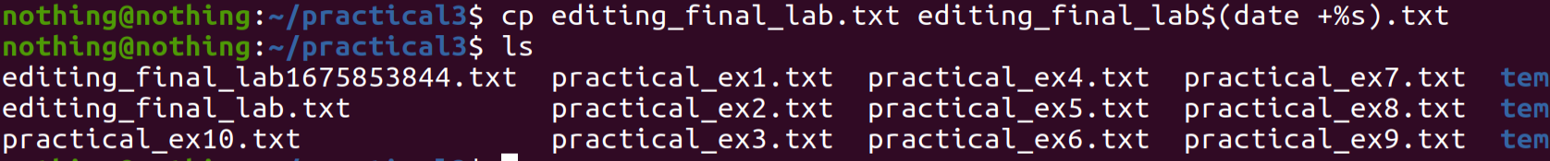

1. He wants to append a dashed line into the file. The dashed line should contain at least 12 dashes.

1. Also need to append a directory listing of the Documents directory. List the directory listing on the terminal and send it to the editing_final_lab.txt file with one command line.

1. Confirm that the directory listing is at the bottom of the lab file.

